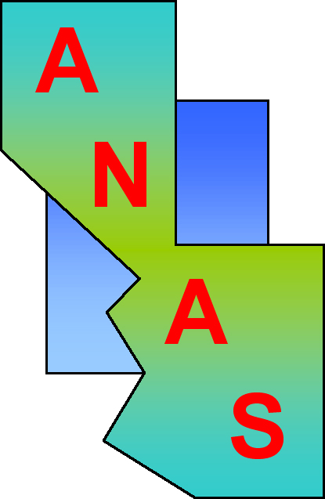
Application for ANAS Student Travel
Reimbursement Grant 2018
Arizona Nevada Academy of Science Annual Meeting
April 21, 2018, University of Nevada, Las Vegas

Student’s name:
Email: Phone:
Mailing address:

Institutional affiliation (including department):
Current ANAS membership: Yes No

Mentor/Advisor’s name:
Email: Phone:
Mailing address:

Institutional affiliation (including department):
Current ANAS membership: Yes No

Current student status:
Undergraduate Year: (select from drop-down menu)
Graduate student (Masters program) Admission date (semester/year):
Graduate student (Doctoral program) Admission date: (semester/year):
Overall Undergraduate GPA:

Meeting registration: (mark one)
General attendee (not a presenter)
First author (Presentation)
First author (Poster)
Author other than first on submitted abstract

ANAS Travel grant in the past:
2018 will be my first meeting; first application for travel
I have received travel reimbursement funds from ANAS to attend a meeting in the past
(Note: All applicants will be considered)
Estimated expenses: Departure date: Return date:
Lodging – total $
Lodging details:
- # nights
- nightly rate
- hotel name?
Travel - total cost $
Travel details:

Driving
Estimated miles round trip:
# people sharing vehicle:
Flying
Airline:
Airfare: (roundtrip):
Per diem costs – total $
Per diem details:
- parking $
- local transportation (cabs, shuttles) $
- meals (other than those provided at no charge at meeting)
Registration fees $
TOTAL ESTIMATED EXPENSES $

In either the fillable space below or on a separate attachment, include a 2-3 paragraph statement explaining the significance of the work you are presenting and your need for financial support (including other sources of support, and grants applied for).

Terms of grant: Expenses listed must be estimates of student’s share of otherwise unreimbursed travel-related costs. Recipients are required to submit copies of their receipts and itemized list of actual expenses to Karen Conzelman, ANAS Treasurer by fax (623-845-4556) or email (karen.ann.conzelman@gccaz.edu ) within week of return for reimbursement [up to amount of grant]. Meals should be listed but no receipts are required.

I understand and accept the terms of this grant: Date:
e-signature of applicant (typed)

Completed of application should be sent to Pam Marshall at pamela.marshall@asu.edu by March 15th. Late and incomplete applications will not be considered. Amount of award will depend on number of applicants and need of each. Applicants will be notified by March 22nd.

